AI INBOUND CALLING AGENT

Project Advisor
Dr. Muhammad Saad Razzaq (Internal)

Project Manager
Dr. Muhammad Ilyas

Project Team
Muhammad Asmaad Saeed | BSCS51F22S037 | Team Lead
Laiba Siraj | BSCS51F22S046 | Team Member
Fatima Zahid | BSCS51F22S010 | Team Member
Areeba Rehman | BSCS51F22S039 | Team Member

Submission Date
8th October 2025

Table of Contents

1. Abstract 3
2. Background and Justification 3
3. Project Methodology 3
4. Project Scope 5
Included Functionalities: 5
Excluded Functionalities: 5
5. High level Project Plan 6
6. References 6

Abstract
The AI Inbound Calling Agent is an Urdu-speaking virtual assistant being developed for the University of Sargodha (UoS). It aims to modernize and automate the university’s telephone-based support system. Unlike existing English-based solutions, it will enable natural Urdu communication to remove language barriers and improve accessibility. Human-operated systems often face high call volumes, long waiting times, and inconsistent service quality. This AI solution will ensure faster, smarter, and more reliable assistance. It will uses Automatic Speech Recognition (ASR), Natural Language Understanding (NLU), Knowledge Graphs, and GraphRAG reasoning to understand user intent and give intelligent responses. The agent will handle routine queries automatically and forward complex cases to human operators, ensuring efficiency and continuous support.

Background and Justification
In today’s digital landscape, customer support plays a central role in shaping user experience and organizational reputation. However, traditional inbound call centers are burdened with long wait times and inconsistent service quality. These challenges are more pronounced in Pakistan, where many users communicate in Urdu or a mix of Urdu-English, yet most automated systems remain English-centric, creating a language and accessibility gap. [1]
With customers expecting real-time, 24/7, and personalized support, organizations are under increasing pressure to optimize resources and improve efficiency. Existing solutions such as AutoCalls.ai offer generic flow-building tools for call automation, but they are not sufficiently adaptable to specialized contexts such as Urdu-first interaction, code-switch handling, emotion and urgency detection, or localized service delivery. [2–4]
To address these gaps, this project will propose the development of a native Urdu-first, agentic AI system specifically tailored to the Pakistani context. Unlike generic work flow builders, the proposed system will integrate Automatic Speech Recognition (ASR), Natural Language Understanding (NLU), and Text-to-Speech (TTS) components with local telephony gateways to ensure low-latency, real-time communication.
By automating routine customer queries and facilitating natural, culturally relevant interactions, the solution will aim to enhance accessibility, service consistency, and user satisfaction within Pakistan’s evolving digital service ecosystem.

Project Methodology
The development of the proposed AI-based Inbound Call-Handling System for the University of Sargodha (UOS) will follow a structured and iterative software engineering approach to ensure quality, adaptability, and efficiency. The project will employ the Agile Software Development Life Cycle (SDLC) model, which emphasizes incremental development, continuous feedback, and modular integration.

Software Development Approach

The Agile SDLC model will be adopted, consisting of multiple short, iterative cycles (sprints). Each sprint will produce a working prototype that can be tested, evaluated, and refined.

Requirement Analysis:
⦁ Collecting functional and non-functional requirements for university-related tasks.
⦁ Identifying use cases such as inquiry handling, merit list queries, admission information, and academic calendar updates.

System and Architectural Design:
⦁ Designing the modular architecture consisting of components like ASR, NLU, Dialogue Manager, Knowledge Graph, and TTS.
⦁ Defining communication protocols (API-based) and message flow through RabbitMQ/Kafka for real-time processing.
⦁ Creating high-level UML diagrams (use case, sequence, and component diagrams).

Implementation and Integration:
⦁ Developing each component incrementally and integrating them using microservice principles.
⦁ Employing Python/Node.js for backend development and frameworks like FastAPI or Express.js.
⦁ Incorporating AI/ML modules (ASR, NLU, and GraphRAG reasoning) using TensorFlow, Transformers, and LangChain.

Testing and Validation:
⦁ Conducting unit testing, integration testing, and end-to-end testing for all modules.
⦁ Evaluating accuracy of speech recognition, response latency, and escalation triggers.
⦁ Testing under real call conditions using telephony APIs (Twilio/SignalWire).

Deployment and Continuous Improvement:
⦁ Deploying the system on cloud infrastructure (AWS/GCP) using Docker and Kubernetes for scalability.
⦁ Implementing continuous monitoring, performance tracking, and model retraining through the analytics pipeline.
⦁ Incorporating user feedback to improve language understanding, tone, and knowledge accuracy.

4.Project Scope

Included Functionalities:
- Automatically answers inbound calls and interacts with callers in real time.
- Uses speech recognition and Natural Language Understanding (NLU) to identify intent and provide accurate responses.
- Supports bilingual communication in both English and Urdu.
- Retrieves essential information from the university’s database, including admission schedules, departmental contacts, office timings, and event details and others.
- Allows seamless call transfer to a human operator for complex queries.
- Provides an analytics dashboard to monitor call volume, response accuracy, and performance based on system logs and user feedback.
- Includes basic emotion and sentiment detection to improve response quality and user experience.

Excluded Functionalities:
- Outbound or promotional calling.
- Video or chat-based communication.
- Integration with socail media or non telephony communication platforms.
- External Support for non-verbal communication modes(e.g,emails,or text chat).

5.High level Project Plan

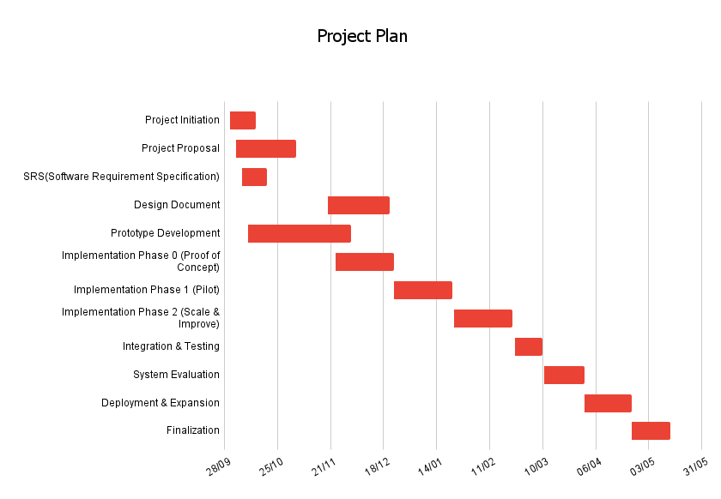

References

[1] | W. Bank, "Pakistan Development Update-Reimagining A Digital Pakistan," World Bank, April 2025. [Online]. Available: https://thedocs.worldbank.org/en/doc/e414b36ae736660edf8f0f3cb597b1e9-0310012025/pakistan-development-update-reimagining-a-digital-pakistan-april-2025 .
[2] | H. B. Review, "Customer experience in the age of AI," Harvard Business Review, March 2022. [Online]. Available: https://hbr.org/2022/03/customer-experience-in-the-age-of-ai.
[3] | P. &. Parloa, "Transforming customer service for a smarter, more human future.," Parloa, 2021. [Online]. Available: https://www.parloa.com/customers/pwc-and-parloa-transforming-customer-service-for-a-smarter-more-human-future/.
[4] | AutoCalls, "AutoCalls AI: Call flow builder.," AutoCalls, 2025. [Online]. Available: https://autocalls.ai/.
[5] | Gartner, "Market guide for conversational AI platforms.," Gartner Research, 2022. [Online]. Available: https://www.gartner.com/en/documents/5332563.
[6] | G. Cloud, ""Speech-to-Text documentation,"," Google, 2025. [Online]. Available: https://cloud.google.com/speech-to-text/docs.
[7] | Wikipedia, ""Natural language understanding,"," WIKIPEDIA, 2025. [Online]. Available: https://en.wikipedia.org/wiki/Natural_language_understanding.
[8] | LangChain, ""LangChain Docs,"," LangChain, October 2025. [Online]. Available: https://python.langchain.com/docs/integrations/retrievers/graph_rag/.
[9] | "Knowledge graph," WIKIPEDIA, 2025. [Online]. Available: https://en.wikipedia.org/wiki/Knowledge_graph.
[10] | 11ElevenLabs, ""ElevenLabs,"," 11ElevenLabs, 2025. [Online]. Available: https://elevenlabs.io/.
[11] | M. O. I. T. &. TELECOMMUNICATION, "Pakistan Personal Data Protection Bill," MINISTRY OF INFORMATION TECHNOLOGY & TELECOMMUNICATION, 2023. [Online]. Available: https://share.google/oUXqmt3btzePKP7hK.
[12] | neo4j, "Neo4j documentation," neo4j, 2025. [Online]. Available: https://neo4j.com/docs/.
[13] | M. &. K. A. &. K. K. &. T. Z. &. A. H. Agro, "Code-Switching in End-to-End Automatic Speech Recognition: A Systematic Literature," 2025.
[14] | M. &. O. J. &. C. K. Kaleem, "Development of UMAIR the Urdu Conversational Agent for Customer Service.," 2014.
[15] | OpenAI, "GPT-5 Technical Report," 2025. [Online]. Available: https://openai.com/.

